RTL Analysis Schematic of RTL version of Lab1_1Buffers

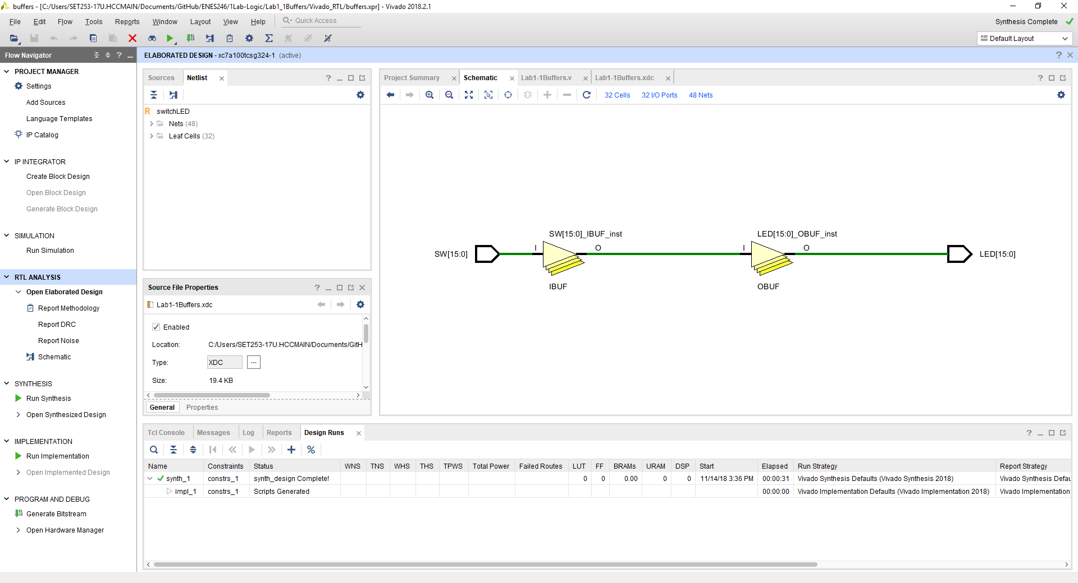

Schematic of RTL version of Lab1_1Buffers

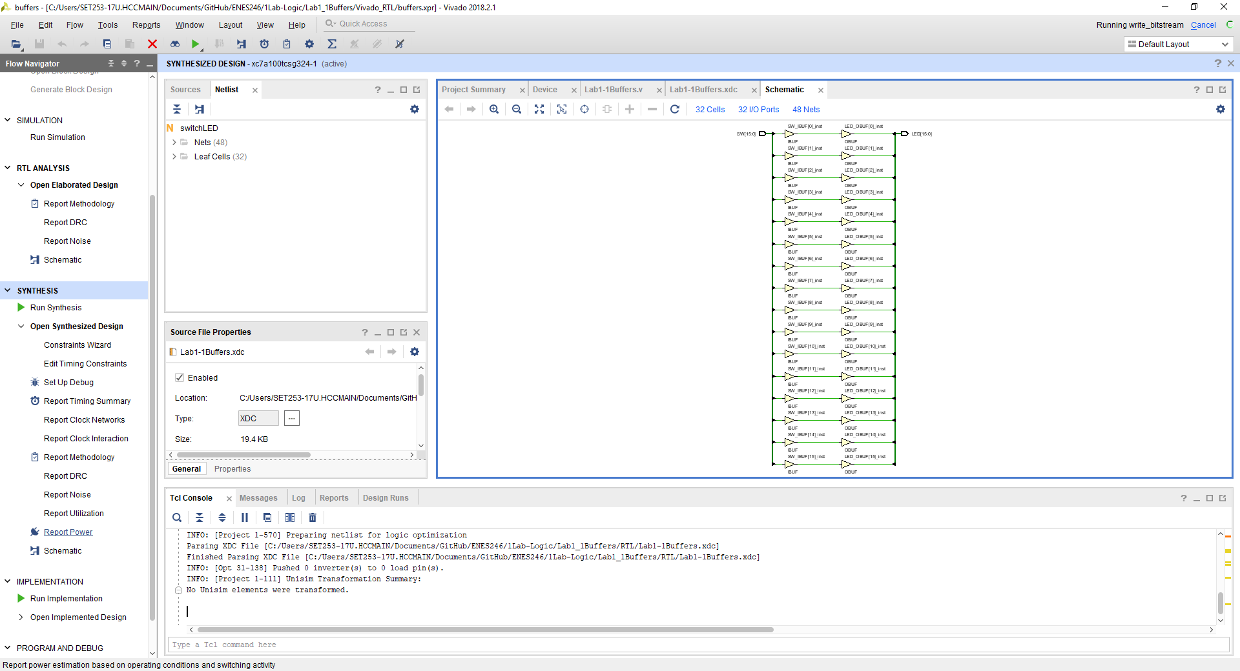

Comments, the triangle symbols are those of buffers the left pointing box with wire coming out are switches or inputs. The left pointing boxes with wire coming into it are outputs.

Everything is identical with the Digital version of this project.